Binary Search

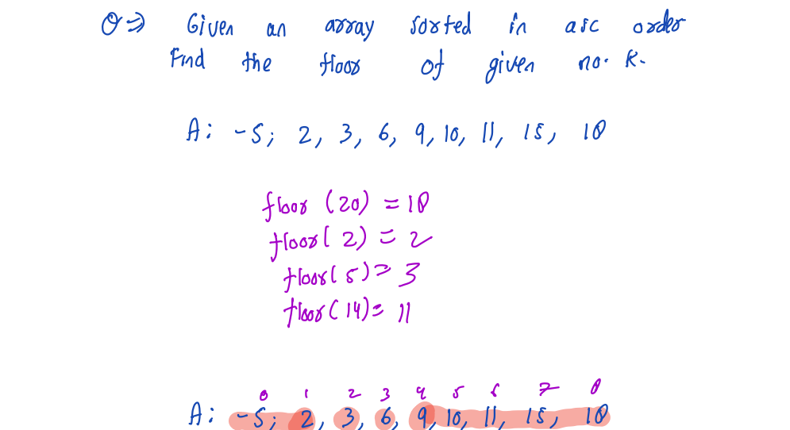

e.g

K = 5

L = 0

R = 8

L R Mid A[mid] A[mid] <= k ans

0 8 4 9 false

0 4 2 3 true 3

2 4 3 3 false

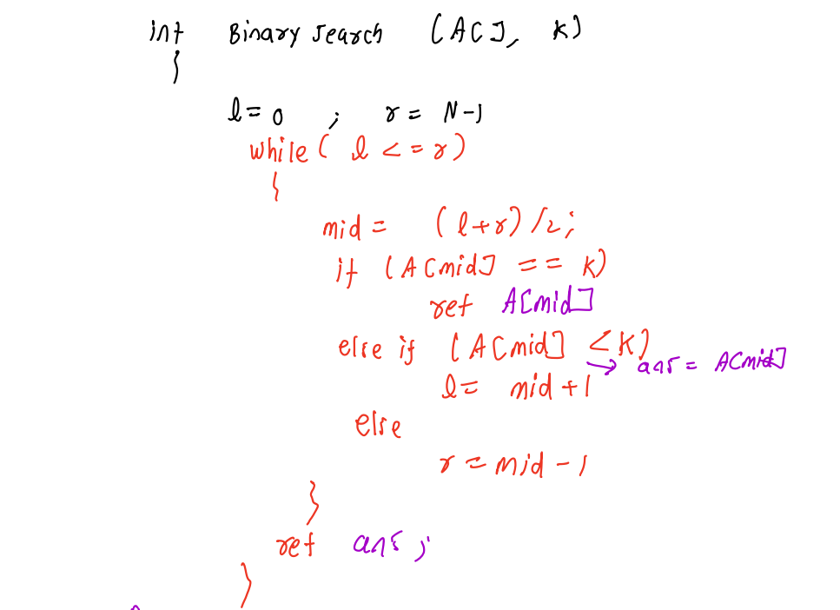

2.) 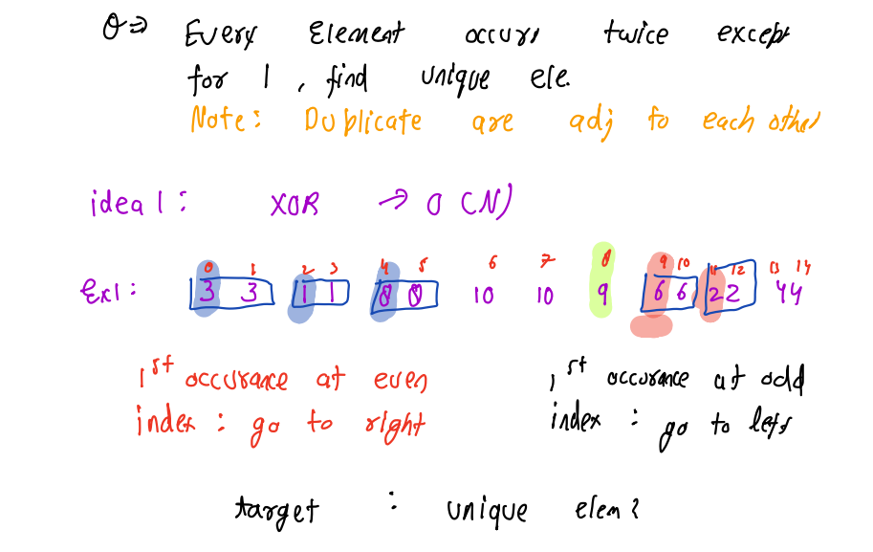

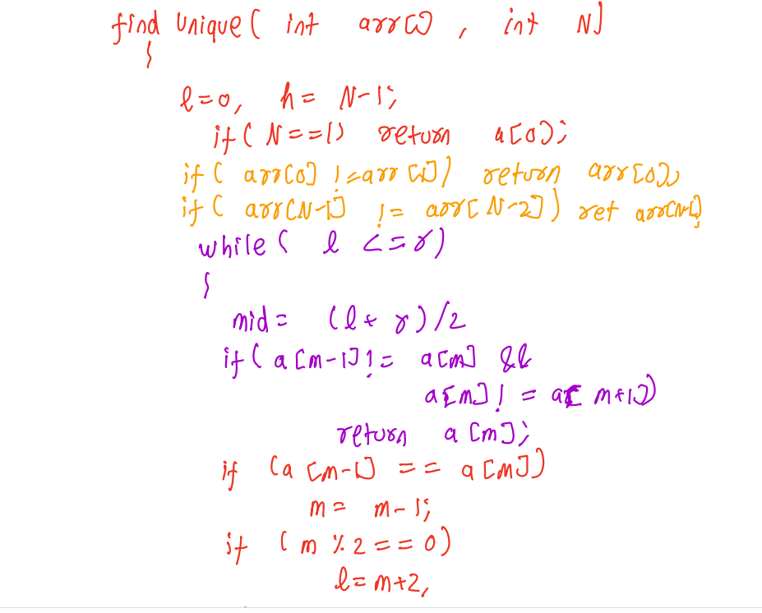



O(1) < O(LogN) < O(N) < O(NLogN) < O(N\*N) < O(2 pow N)